Count Operations to Obtain Zero
Platform: LeetCode
Language: C
Module 3, Question 3

Problem Link
https://leetcode.com/problems/count-operations-to-obtain-zero/

Problem Statement
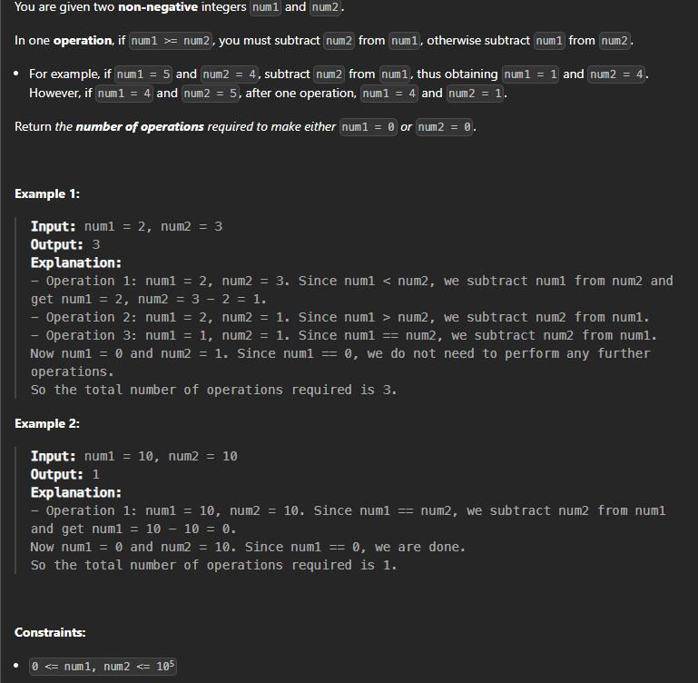

C Code
int countOperations(int num1, int num2) {
int count = 0;
while (num1 != 0 && num2 != 0) {
if (num1 >= num2)
num1 = num1 - num2;
else
num2 = num2 - num1;
count++;
}
return count;
}

Screenshot of Successful Submission



